Elsie Bertram Diabetes Centre

Reviewing and Sharing Libre Data

Due to the current restrictions that are in place, we are running our clinics remotely.
To assist with your consultation, we would like you to upload your blood glucose results at home through Libre View.

Please follow the steps below in order to share your blood glucose readings with the Elsie Bertram Diabetes Centre.

The clinic code for Elsie Bertram Diabetes Centre is 01603288513, which you will be required to input at step 6 ‘Linking your LibreView account to your clinic’.
Please note that the data you share with us will be used for no other purpose other than to support your own care.
Useful Information:

Information for libre view (including technical advice): www.libreview.com
For advice in relation to your diabetes please contact the Elsie Bertram Diabetes Centre:
Non urgent advice Monday to Friday (09:00-16:30) - 01603 288513
Website: https://www.elsiebertramdiabetescentre.org.uk

Are you using the LibreLink app on your phone to scan your Libre sensor?

- YES - go to step 5
- NO - go to step 2
Step 1

Have you set up a LibreView account?

- YES - go to step 4
- NO - go to step 3

Step 2

Step 3 Setting up a LibreView account
- Go to www.libreview.com
- Click the sign up button (see A below)
- Select ‘LibreView Account’ (see B below)
- Follow the on-screen instructions regarding country of residence, accepting the terms of use (user agreement and privacy policy), enter your name and date of birth, create a password and respond to the verification email sent to you by LibreView.
- You can now log-in with your email and password – go to STEP 4

A

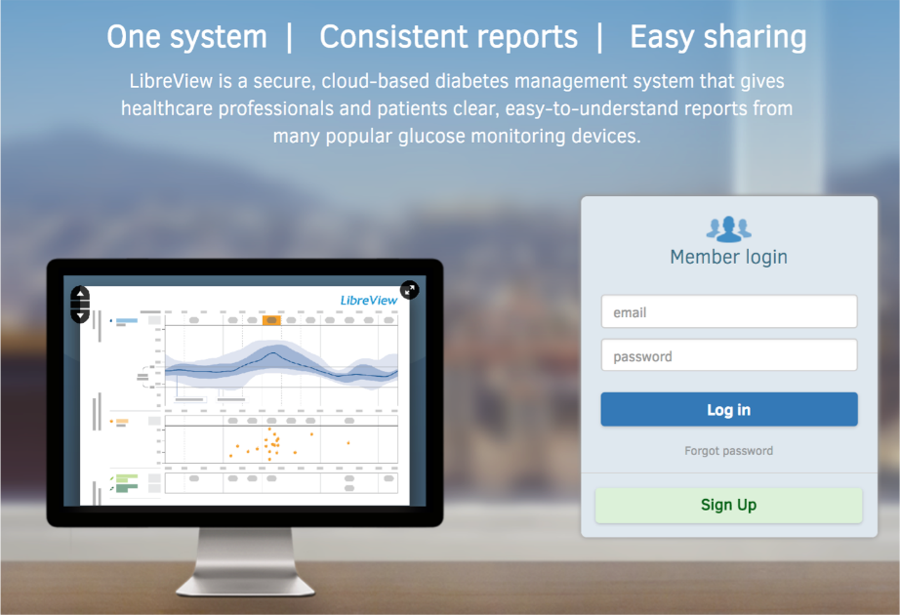

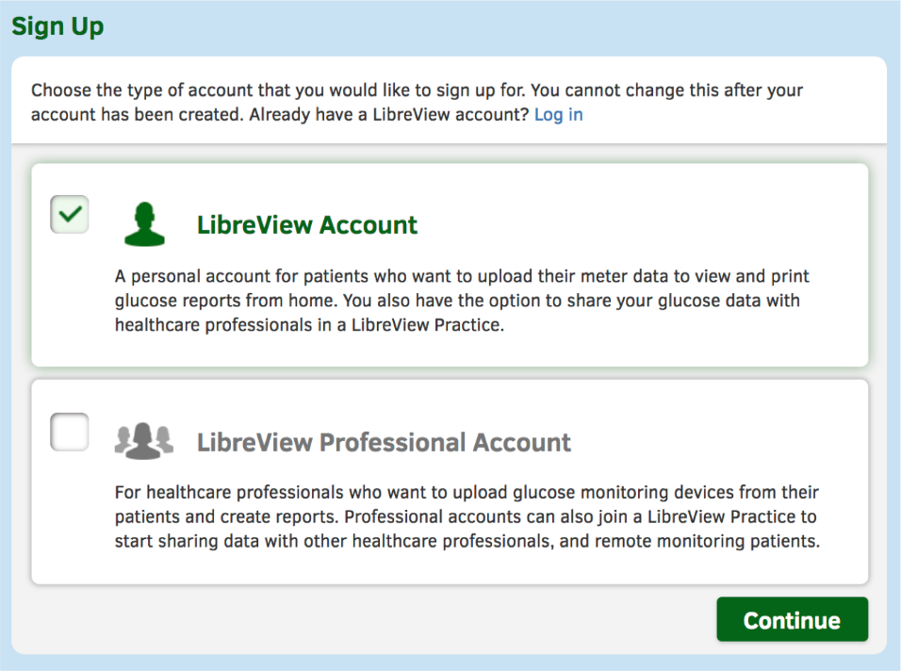
B

Step 4 Uploading your reader data
When logged in, connect your Libre reader to your computer with the supplied USB cable.

Click the green ‘Upload’ button (see C below) and follow the on-screen instructions to upload your Libre data.

IMPORTANT: You also need to link your LibreView account to your clinic’s account – go to STEP 6 to do this now.

C
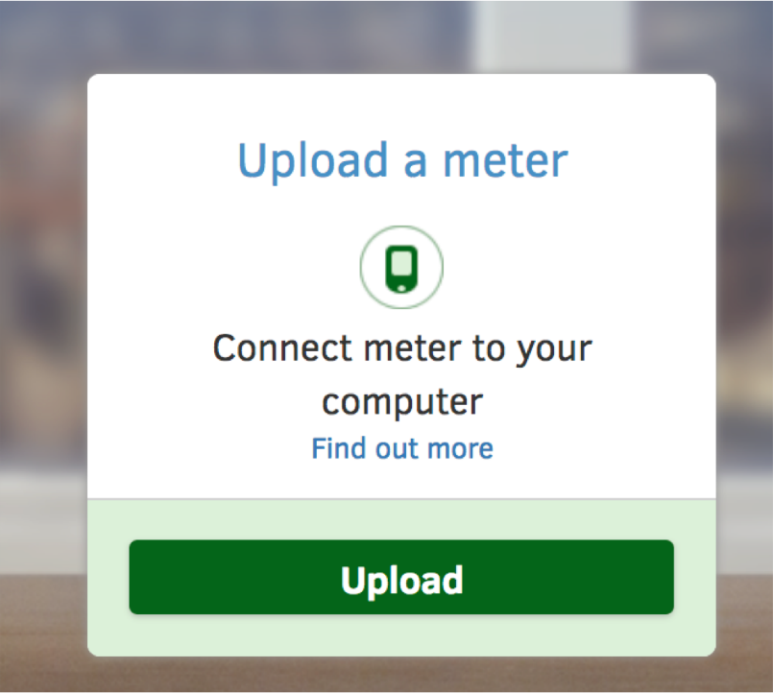

Step 5
If you have set your phone up to scan the sensor, please log in to www.LibreView.com (using the same email and password that you use on your LibreLink phone app).

Now move to STEP 6.

When logged in to your LibreView account click at the top right corner (see D below) and then open up ‘Account Settings’ (see E below). Click the tab ‘My practices’ (see F below) and in the ‘Link to a practice’ box type in the code 01603288513 and click ‘Add’.

This will link your Libre account to your clinic’s LibreView account.

If you are only using your phone to scan the Libre sensor this is all you need to do.

IMPORTANT: If you are using a Libre reader (i.e. not using your phone to scan), upload your data as described in STEP 4.

Step 6 Linking your LibreView account to your clinic

D
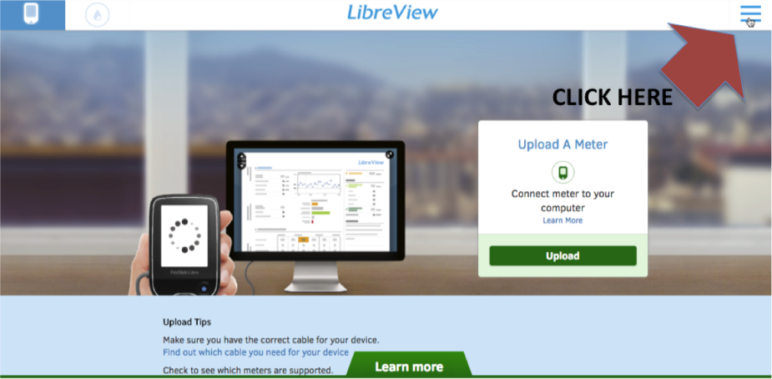

E
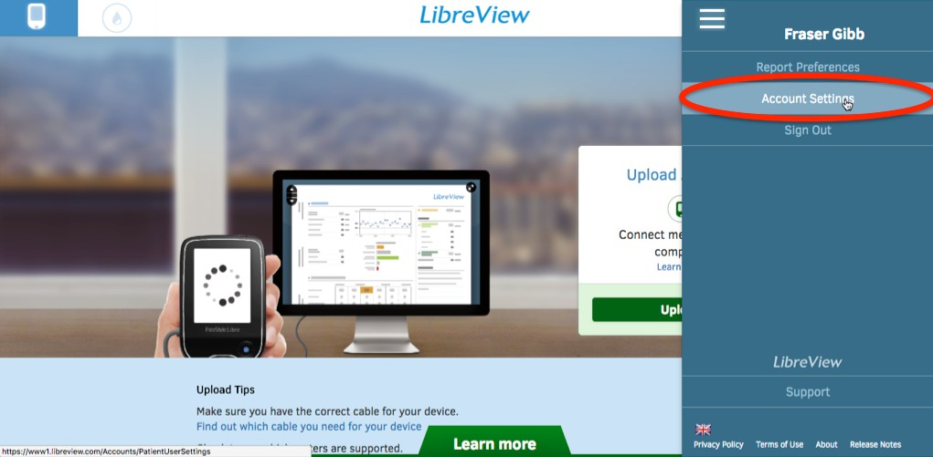

F

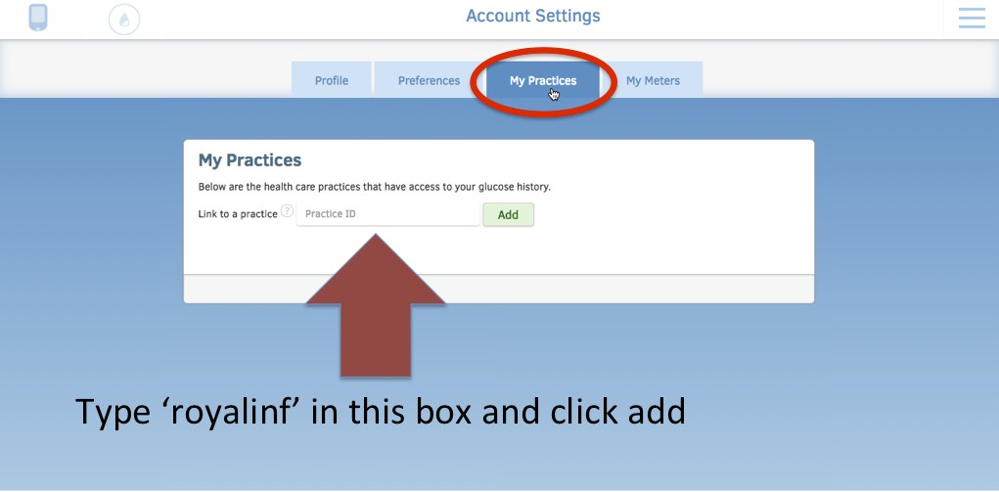
Type your clinic’s code here and click ‘Add’

If you have trouble getting any of this to work, click the ‘support’ option



