Elsie Bertram Diabetes Centre
InnoLet
Patient Information Leaflet

This patient information leaflet is intended as a guide. For full information about your device, please refer to the more detailed leaflet in the product pack.
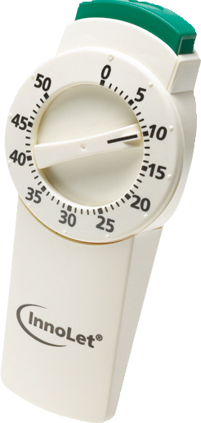

How to use your InnoLet Device:

- Remove the cap of the InnoLet
- Suspend the insulin in the device reservoir
- Turn the device carefully up and down between positions A and B so that the glass ball inside the reservoir moves from one end to the other
- Repeat this movement at least 10 times.
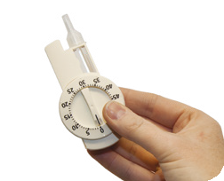
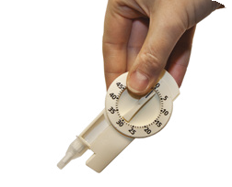
A
B

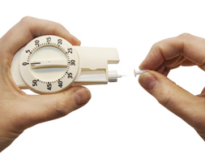

- Attach a new needle to InnoLet and take off both protective needle caps.

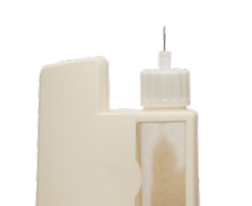
- Remove air from the system by:
- Dialing 2 units by turning the do selector clockwise.
- Pointing the device in the air.
- Pressing the push-button all the way in.

A drop of insulin should appear at the needle tip.
If not, repeat the procedure up to a maximum of 6 times.
If a drop still does not appear, the device must not be used.
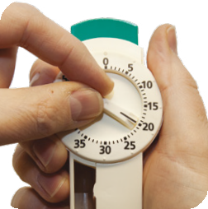
- Check one more time that the push- button is fully depressed and that the dose selector is set to zero.

- Dial the number of insulin units required (up to 50 units) by turning the dose selector clockwise.

- The dose can be corrected both upwards and downwards.

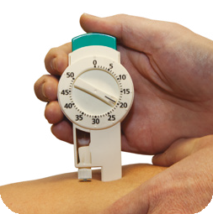
- It is not possible to select a dose larger than the number of units of insulin remaining in the reservoir.

- Inject your insulin into the subcutaneous fat (beneath the skin), in your abdomen, thighs or buttocks. It is important to rotate your injection sites. If you do not, your skin may become lumpy and the insulin will not be absorbed properly.

- Insert the full dose by depressing the push-button fully.

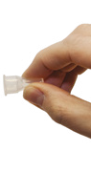
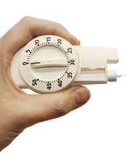
- Wait for at least 6 seconds before withdrawing the needle.

- Remove the needle after each injection.

- Put the conical shaped outer needle cap on and unscrew the needle.

- Discard the needle carefully.

Where to store insulin:
- Unopened supplies of insulin should be kept in the door of the fridge.

- Opened insulin you are using should be kept at room temperature in a cool dry place out of sunlight.

- If you have not used the insulin that has been opened and out of the fridge after one month you should discard the opened insulin.

- Always check the expiry date of your insulin.

Testing your blood glucose levels:

You will be advised how often to take you blood glucose.

What to aim for:
- Fasting: below 5.3mmol/l
- One hour after meals: below 7.8mmol/l

Contact details:
Diabetes Specialist Midwives (non-urgent, answer phone) 01603 286802
Diabetes Specialist Midwives (Bleep) 01603 286286 ask for bleep 0849 (Monday to Friday 09:00-16:30)
Diabetes Specialist Nurse (Bleep) 01603 286286 ask for bleep 0518 (Monday to Friday 09:00-16:30)

Useful resources:
Diabetes UK- www.diabetes.org.uk
EBDC website- https://elsiebertramdiabetescentre.org



